# **Screen images of the code – UiPath – Robotic Process Automation**

Image 1 : Displays the end to end code from UiPath Studio Designer

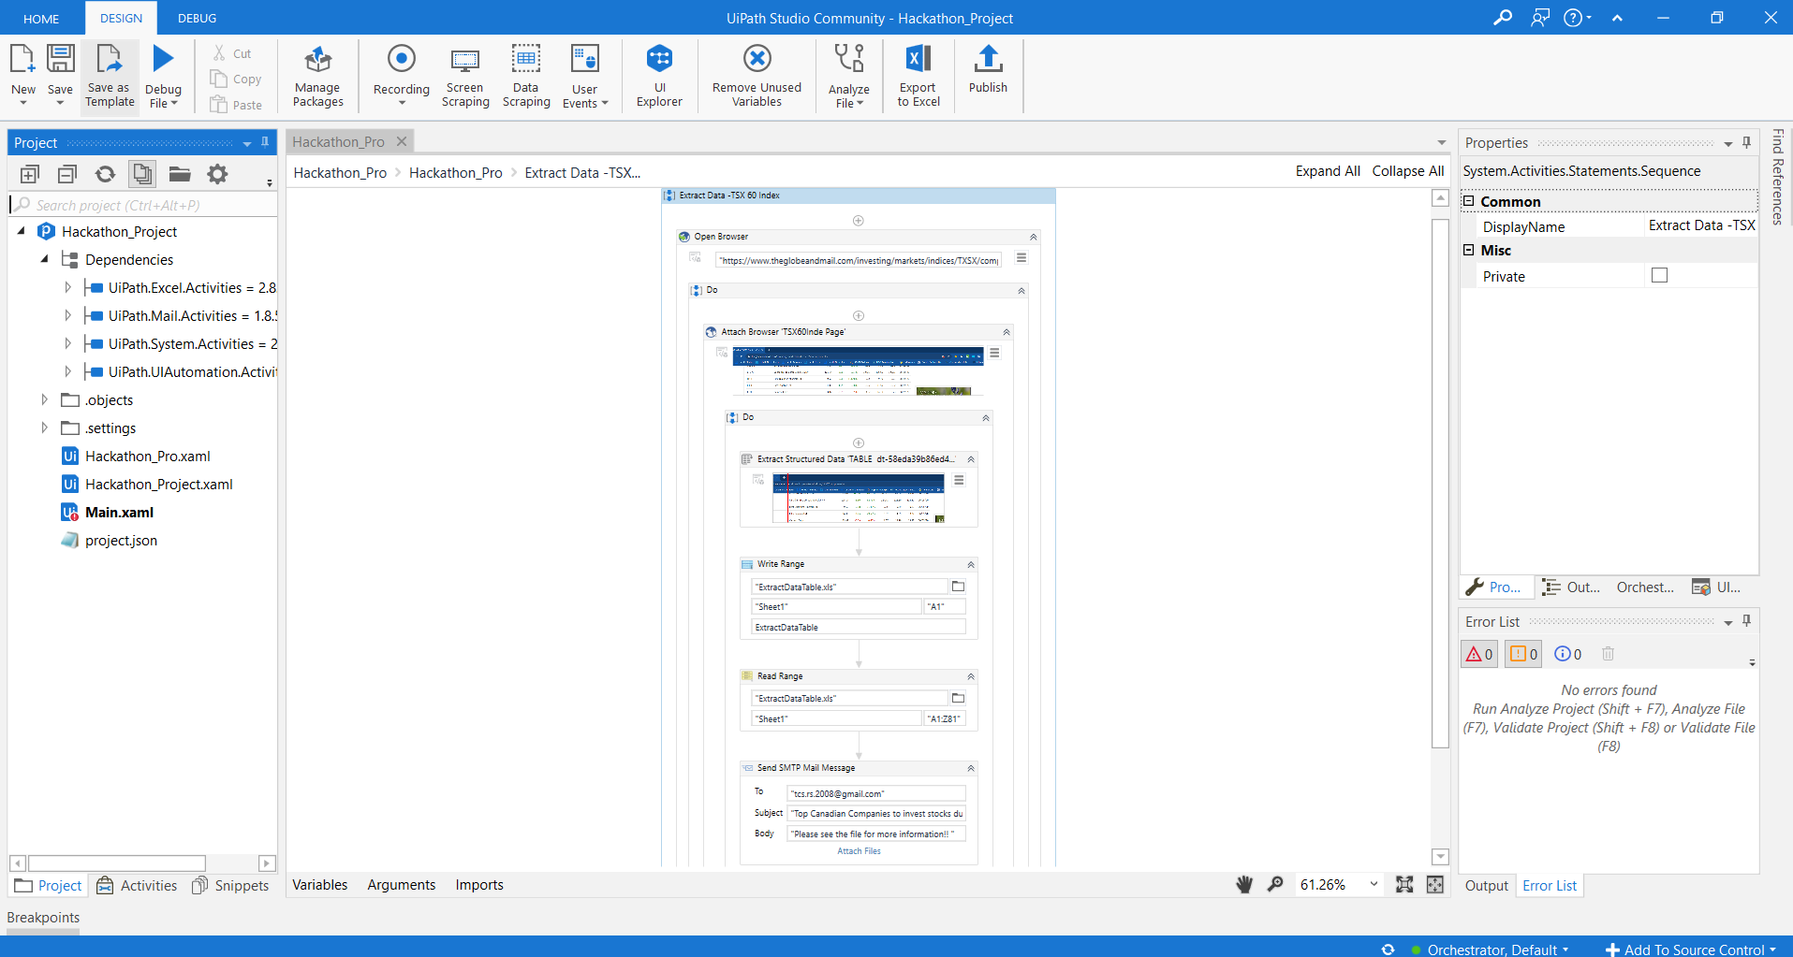

Image 2: Below image displays the code inside “Extract Data -TSX 60 Index”code block, where the bot logs into the webpage - <https://www.theglobeandmail.com/investing/markets/indices/TXSX/components/> and then extracts the Table information for the TSX 60 INDEX. Please refer to image 2.1

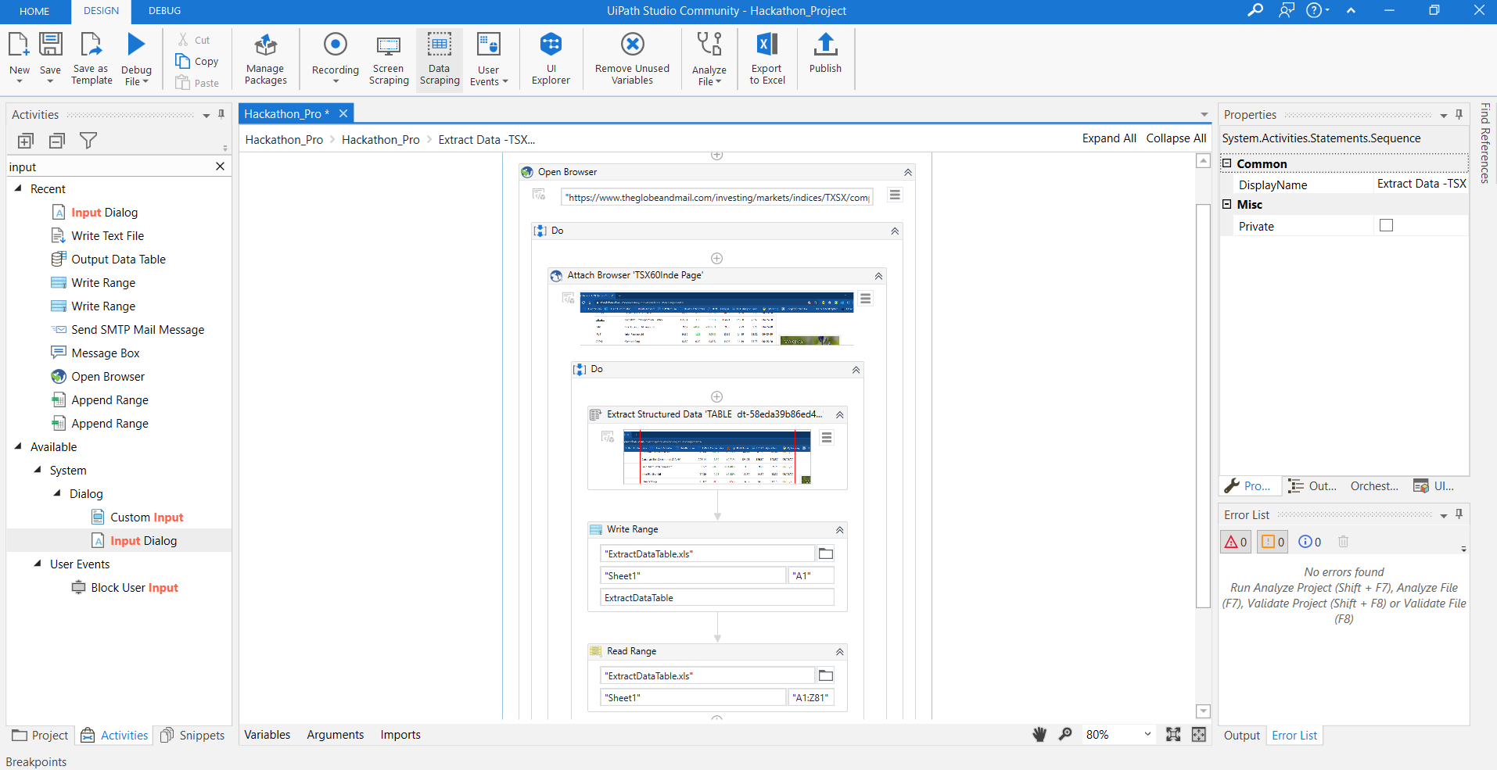

Image 2.1 The extracted table data from TSX 60 Index is then extracted to a datatable using the variable – ***ExtractDataTable***

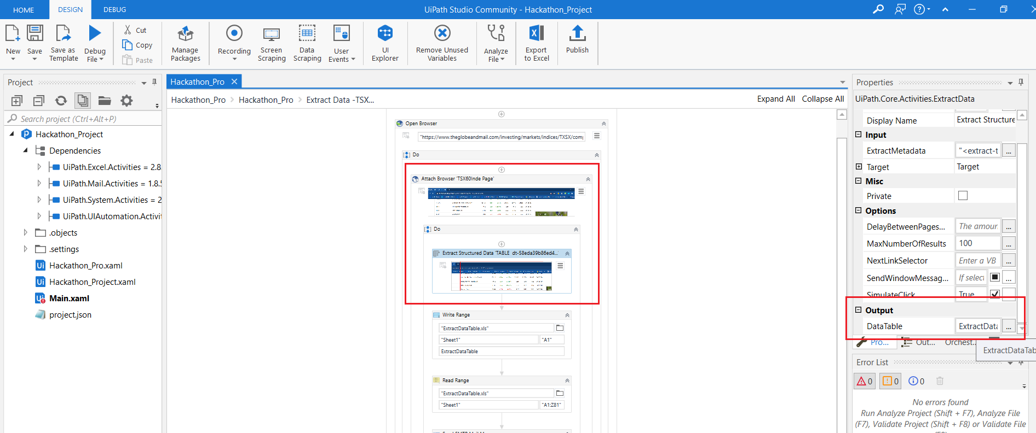

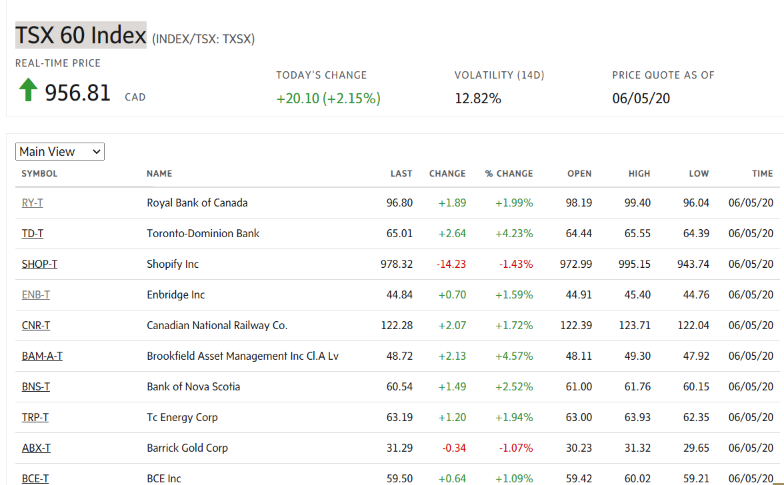

Image 3: The data from the datatable is then moved to a excel file - ExtractDataTable

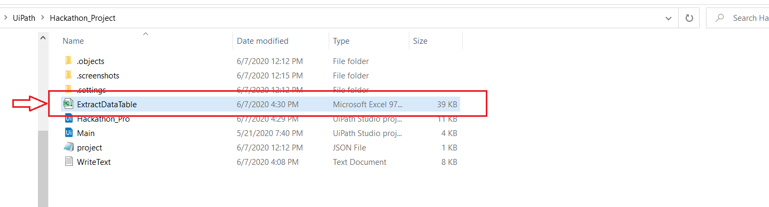

Image 5: Using the SMTP Uipath Activity, the excel file is then sent to a investors email addresses, who would be interested to track the Canadian Stock Index - TSX 60 Index (Instrument ExchangeINDEX/TSX: Instrument SymbolTXSX)

